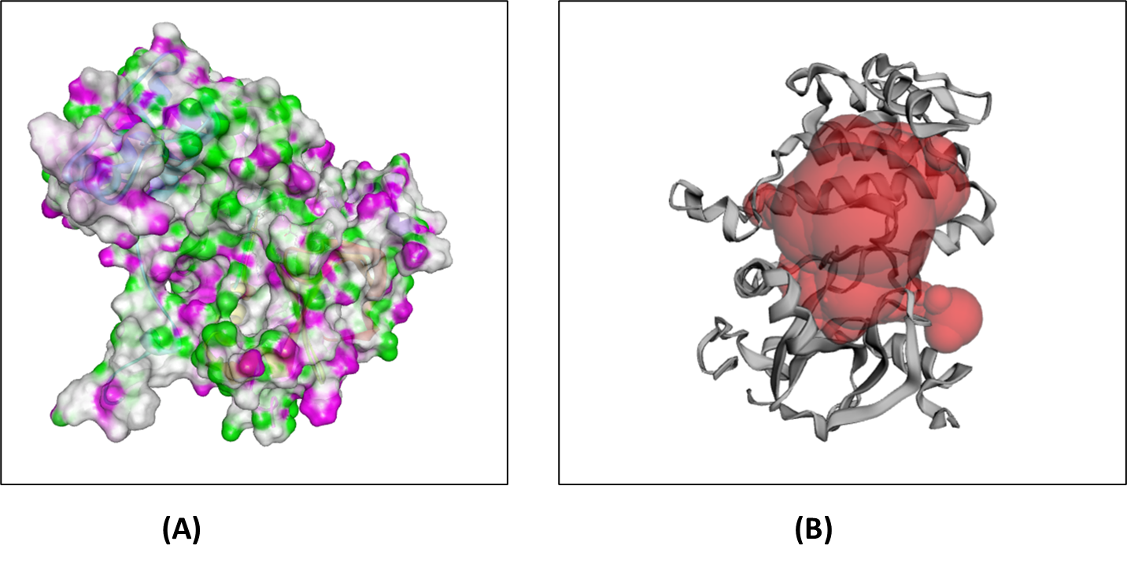

**Supplementary figure S1.** **(A)** Target protein AURKB (PDB ID: 4AF3) in a three-dimensional conformational image, colored by amino acid type, from the development of breast cancer. pink represents a hydrogen bond donor, and green represents an acceptor of hydrogen bonds**. (B)** Active site of the human aurora kinase B protein molecule as predicted by CASTp.